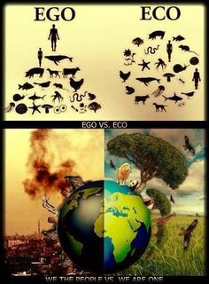**Unit 1:  Human Impact:  Cause and Effect   
(4 weeks)**

SEV4. Obtain, evaluate, and communicate information to analyze human impact on natural resources.  
     a. Construct and revise a claim based on evidence on the effects of human activities on natural resources.  
     b. Design, evaluate, and refine solutions to reduce human impact on the environment including, but not limited to, smog, ozone depletion, urbanization, and ocean acidification.

Essential Questions:  
 1. How does pollution affect land, air, and water?  
 2. How does air pollution affect water resources?  
     
Intro to Land Resources: Semester I (Aug. 17- 21), Semester II (Jan. 11- 15)

*Formative Assessment Aug. 19, 21/ Feb. 11*

Learning Goals  
I can obtain, evaluate, and communicate information to analyze human impact on natural resources.

I can construct and revise a claim based on evidence on the effects of agriculture, forestry, ranching, mining, urbanization, and pollution on land and organisms.  
(Lesson 1.1)  
[Unit 1 Vocabulary List](https://www.astephensscience.com/uploads/4/0/7/3/40734789/unit_1vocabulary2017.docx)  
Text References:  
Chapter 1 Section 1 pgs. 14–15  
​    [Chapter 1 ppt](https://www.astephensscience.com/uploads/4/0/7/3/40734789/ch01_sec1_revised.ppt)  
    [Chapter 1 guided notes](https://www.astephensscience.com/uploads/4/0/7/3/40734789/chapter_1_section_1_day_1_guided_notes.docx)  
Engage: [Georgia Land Use interactive map](http://narsal.uga.edu/glut/data-stats/georgia-landcover-trends)  
     Questions:  
           1.What are the key patterns in land use change in Georgia?  
           2 .What are the causes and effects of these patterns?    
Lab Activity:  
Complete a mining lab using cookies.  
Link: <http://www.earthsciweek.org/classroom-activities/cookie-mining>

This lab demonstrates for students the considerations that must take place when using land as a natural resource.  
Cookie[Sheet:  
Mining for Chocolate activity](https://www.astephensscience.com/uploads/4/0/7/3/40734789/lab-sheet-mining-a-chocolate-chip-cookie.docx)  
<http://www.earthsciweek.org/classroom-activities/cookie-sheet>  
  
Homework:  
Evaluate: Choose one of the following writing prompt to summarize the importance of land and organism conservation. 

Prompt 1: It is estimated that we are losing 137 plant, animal and insect species every day due to the deforestation of rainforests. That means we are losing over 50,000 species every year. The reason the land is being cleared is for the timber, for mining operations and to provide grazing areas for large scale cattle ranching. What do you think can or should be done to stop the deforestation?

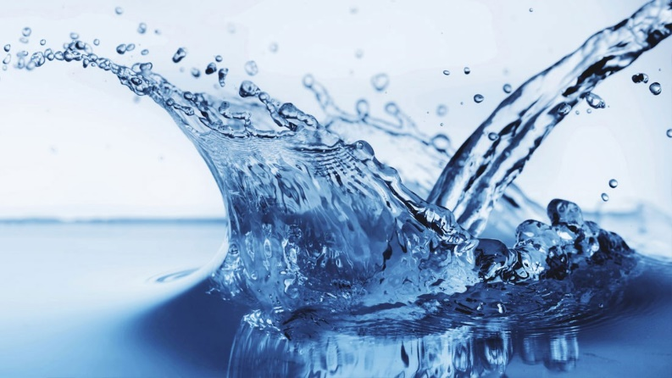Prompt 2: A tract of land is being sold in your community. Fictitious bidders include the National Park Service, a children’s hospital, a shopping-mall developer, an oil drilling company, and the U.S. Armed Forces. Choose one and become a lobbyist for one that group writing arguments on behalf of their interests.  
  
​  
[​](https://www.astephensscience.com/uploads/4/0/7/3/40734789/lab-sheet-mining-a-chocolate-chip-cookie.docx) Introduction to Water Resources: (August 24-28) / (Jan. 18 - 22)

*Formative Assessment Aug. 26, 28. / Jan. 22*

Learning Goals:  
1. I can obtain, evaluate, and communicate information to analyze human impact on natural resources.

2. I can construct and revise a claim based on evidence on the effects of fishing, water use, desalination, and waste water treatment on water and organisms.  (Lesson 1.2)  
Lesson 1.2 (Water)  
  
Classroom Activity:  
Overfishing Link to Activity: <https://serc.carleton.edu/eslabs/fisheries/4.html>  
Link to Article: [https://www.nefsc.noaa.gov/history/stories/groundfish/grndfsh1.html#art](https://www.nefsc.noaa.gov/history/stories/groundfish/grndfsh1.html%23art)  
  
Hands-On Lab:  
     Water Quality testing in the classroom  
Virtual Lab option:  
   Students will engage in a virtual lab to test water and document their findings for each sample.  
Link: <http://www.glencoe.com/sites/common_assets/science/virtual_labs/CT04/CT04.html>  
  
Guiding Questions:  
1. What other issues can water have besides too much lead?  
2. How does the treatment process address issues with the water quality?  
​        
Homework:  
Use the following writing prompt to summarize the importance of water and organism conservation.  
Prompt:  
Water is life. There is the same amount of water now on Earth as when it was first created. For us, it’s easy...We turn on the tap and there it is. Yet in Africa and Asia, women and children spend about 6 hours a day and walk an average of 3.7 miles a day just to collect water, according to water.org. Think of five ways you and your family could conserve water so that everyone can do their part.  
  
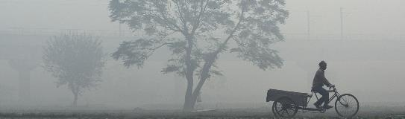Introduction to Air Resources: (August 31-Sept 5)/ (Jan. 25-29)

*Formative Assessment Sept. 3, 5 / Jan. 28*

Learning Goals:  
1. I can obtain, evaluate, and communicate information to analyze e human impact on natural resources.

2. I can construct and revise a claim based on evidence on the effects of agriculture, forestry, ranching, mining, urbanization, and pollution on air and organisms. (Lesson 1.3)  
Video: [China's toxic smog](https://youtu.be/2nFZaSbkf0U)   
Guiding Questions:  
        1. What did you observe?  
        2. What are some of the effects of air pollution in North China?  
        3. Why do you think that China is so polluted?  
Activity: The State of Air  
Link: <http://www.stateoftheair.org/>  
Investigation Handout: State of the Air.pdf  
Begin to reason and understand that there are multiple issues factors that cause air quality issues. This activity will help you understand that there are multiple factors and that some of the factors have a greater impact than others.  
Guiding Questions:  
         1. What is ground level ozone and what effects does it have?  
         2. What are particulates and are all particulates harmful?  
  
Video Reference:  
<https://youtu.be/iCbylY2XyEs>(Overuse of Land)  
<https://youtu.be/DwcW12J1FFA>(Urbanization)  
<https://youtu.be/vWEAd4HLV-g>(Overfishing)  
<https://youtu.be/-V4D77N3bZc>(Overfishing: Planet Ocean)  
<https://youtu.be/11oawjSncYM>(Air Pollution Video)  
<https://youtu.be/Z5Db5ranTXw>(Acid Rain)  
  
  
Human Impact: Project Base Learning (Sept. 7-11) / (Feb. 1 – 5)

*Formative Assessment Sept. 11/ Feb. 5*  
SEV4. Obtain, evaluate, and communicate information to analyze human impact on natural resources.  
b. Design, evaluate, and refine solutions to reduce human impact on the environment including, but not limited to, smog, ozone depletion, urbanization, and ocean acidification.  
Learning Goals:  
1. I can design, evaluate, and refine solutions.

2. I can to reduce human impact on the environment including, but not limited to, smog, ozone depletion, urbanization, and ocean acidification. (Lesson 2.1)

Essential Questions:  
     1. What information did you use from prior lessons to decide which problem you consider the most important to reduce?    
     2 .Which resource (land, water, air) is most effected by smog, ozone depletion, urbanization, and acidification?  
    
Chapter 2 Section 3 pgs. 38–42  
  
Video: [What do Environmental Engineers do?](https://youtu.be/MUT8zya53Vg)  
Guided questions:  
      1.How would you describe the job of an environmental engineer?  
Performance Assessment:  Design and Engineer a process that solves a problem related to human impact on land, air, water, and organisms.  
Project Resource:  
[Water Filtration Project](https://www.astephensscience.com/uploads/4/0/7/3/40734789/water_filtration_-_activity_-_www.teachengineering.pdf)  
  
Claim-Evidence-Reasoning (CER)  
Claim: Statement that answers the question.  
Evidence: Information that supports the claim. Scientific data comes from observations in natural settings or controlled experiments, measurements, or valid scientific sources. Personal information comes from opinions, beliefs, and everyday experiences.  
Reasoning: The justification that links the evidence to the claim. It explains why the evidence supports the claim. Scientific reasoning includes a scientific principle.  
  
Informational Texts Resources:  
News Articles:  
[http://www.smithsonianmag.com/travel/is-the-livestock-industry-destroying-the-planet-11308007/(Land Use and Agriculture)](http://www.smithsonianmag.com/travel/is-the-livestock-industry-destroying-the-planet-11308007/)  
  
<http://apps.seattletimes.com/reports/sea-change/2013/sep/11/pacific-ocean-perilous-turn-overview/>(Ocean pollution)  
  
<http://www.foodispower.org/pollution-water-air-chemicals/>(AllPollution and food)  
  
<http://grist.org/basics/bad-acid-trip-a-beach-bums-guide-to-ocean-acidification/>(Acidification article)  
  
<https://ensia.com/features/what-does-ocean-acidification-mean-for-sea-life/?viewAll=1>(Ocean Acidification and Sea Life)

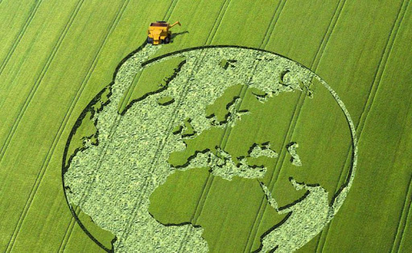<http://www.motherjones.com/politics/2013/05/arctic-ocean-rapidly-getting-more-acidic/>(Ocean Acidification)  
  
Human Impact: Food and Agriculture (Sept.14-18) / (Feb. 8-12)

*Formative Assessment Sept. 16 / Feb. 11*  
SEV4. Obtain, evaluate, and communicate information to analyze human impact on natural resources.  
        c. Construct an argument to evaluate how human population growth affects food demand and food supply (GMOs, monocultures, desertification, Green Revolution).

Learning Goals:  
1. I can obtain, evaluate, and communicate information to analyze human impact on natural resources.

2. I can construct an argument to evaluate how human population growth affects food demand and food supply. (Lesson 3.1)  
         Essential Questions:  What affect does scarcity of food have on food quality?  
  
[Vocabulary (Lesson 3)](https://www.astephensscience.com/uploads/4/0/7/3/40734789/lesson_3_vocabulary.docx)  
[Agriculture and Farming Activities  
​](https://www.astephensscience.com/uploads/4/0/7/3/40734789/hunger_activities_-_agriculture_and_farming.pdf)[Farming for the Future Activities  
​](https://www.astephensscience.com/uploads/4/0/7/3/40734789/15.farming.future%5b1%5d.pdf)[The complex causes of famine resource doc](https://www.astephensscience.com/uploads/4/0/7/3/40734789/causes-of-famine.pdf_good_worksheet.pdf)  
[Famine Research Project](https://www.astephensscience.com/uploads/4/0/7/3/40734789/famine-activity.pdf)  
[Famine Research Project Rubric](https://www.astephensscience.com/uploads/4/0/7/3/40734789/final_environmental_science_project_rubric.docx)  
GMO Article [genetically_modified_food_benefits_and_disadv.205133728.doc](https://www.astephensscience.com/uploads/4/0/7/3/40734789/genetically_modified_food_benefits_and_disadv.205133728.doc)  
  
Unit 1 Summative Assessment:  September 17, 2020